**Mrs. Makowiec’s**

**Kindergarten Class**

**Student Supply List**

**2021-2022**

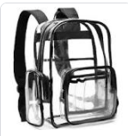

* **clear backpack**

**(mochila transparente)**

* **lunchbox/lunchbag**

**(bolsa del almuerzo)**

* **earbuds or over-the-ear headphones**

**(audífonos o audífonos para colocar sobre las orejas)**

* **kid scissors**

**(tijeras para niños)**